Pirate Sea

“Yay”, the kids screamed excited to go to the park this afternoon. John and Michael are hopping in the car with their foam sords ready to go. When they arrived John and Michael went to the play area in the park and went to go on the rock-climbing mountain and pretend it was an enormous ship ready to defeat some enormous sea monsters.

As the imagination took over, Pirate John and Pirate Michael were at the top of the mountain. Pirate John started running, for a sea dragon was running after him because he stole its pieces of eight. Pirate Michael is running as fast as he can with his sord in his hand trying to attack the sea monster, but he slipped. Pirate John leaped with terror in his eyes hoping he would go to Pirate Michael in time before he falls down from the ship into the water. Sadley, Pirate John couldn’t get there in time, so they stopped playing to check if Michael was alright, luckily Michael was fine he just got a really tiny scratch, so they continued to play.

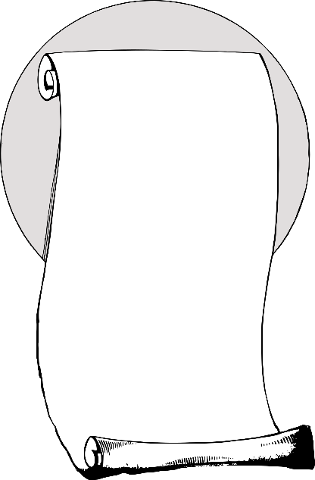
Suddenly, they were lost in the 5 oceans, surrounded by rocking water. A huge, tremendous wave was coming, filling the boat with water and fear. Scaredy, Pirate John and Pirate Michael approached real pirates. Captain Christopher Columbous got his cannon aiming at the two little pirates. The little pirates, with their eyes closed, tried to point with their sords at the captain to scare him away. “Hahaha” captain laughed. He wasn’t scared at all. The little pirates thought they were in big trouble. Then. captain understood that they weren’t here to cause any harm, so he told his pirates to pack the cannon, and they did. Then the captain then went of with his trip for looking for India. A bigger wave was coming recking the ship, after sinking to the Davy jones locker. Pirate John and Pirate Michael sawm to the closed island feeling like someone has marooned them. After hours and hours waiting on the stranded island there was no one, there was nothing. They found an empty bottle, so they took it and they got a piece of bark and carved a note. The note said this: If you find this

please search all the

stranded islands

Captain Jhon and

Captain Michael are lost.

After a while they heard a noise saying “John, Michael it’s time to go home” their mum called. They woke up, relieved it was a dream, so they got their sords and went home.

