**Day 1 – Creative Idea Generation for Narrative & Persuasive Writing**

Create a mindmap based on the stem shown in class and then write 100-200 words describing the narrative story you have decided to write. Ensure you focus on creating descriptions using imagery  
  
Slides: <https://drive.google.com/drive/folders/1CrepmXht9QjxvnuPGIofQio3tWoGdCCn?usp=sharing>

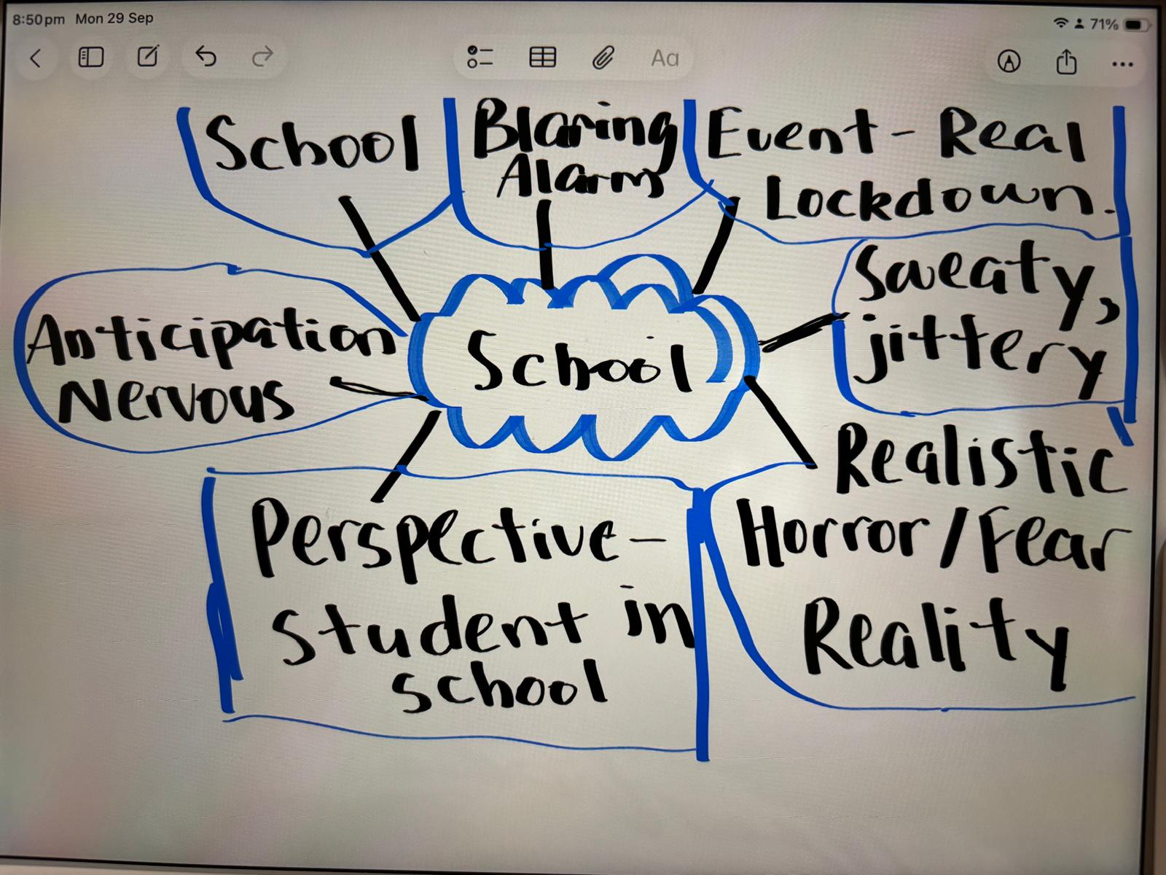

Fourth period just ended and the hallways buzzed with the usual chaos : the slamming of lockers, students chatting between classes and a teacher yelling at a student to stop running. I was on my way to my locker when suddenly, the intercom crackled and Principal Franklin’s voice boomed over the speakers “Students and teachers, this is a lockdown. Initiate lockdown procedures and stay clam. This is not a drill.” For a second, no one moved and everything paused.

Then, everything happened at once, Mrs Patel opened her classroom door pulled me into her classroom, locking the door and shutting the blinds behind us. “Get down. Against the wall. Stay silent.” Mrs Patel whispered. “What’s happening? Am I going to die this early at this school?” I asked myself, questions started racing through my head and my head was pounding. Every whimper and breath seemed so loud, like breathing a bit too deep would attract the intruder’s attention to come to our room. Time seemed to stretch out. Seconds turned into minutes, minutes turned into hours.

There were about twenty of us, crammed up against the back wall of the classroom, trembling with fear. My phone buzzed in my pocket. I slowly drew it out and read “Are you ok?” From my mum. All of a sudden, the school’s instagram page blew up, “What’s happening? Is this real” and more questions flooded into my head. I looked to the front of the class where Mrs Patel was sitting, slowly filling in the lockdown form with trembling fingers. When we locked eyes, she gave me a weak smile. “Maybe there was a bit of hope.” I thought.

Suddenly, our room’s doorknob rattled. Then, there was a loud bang on the door, followed by another. All the noise coming from the outside was suddenly muffled and replaced with my rapid heartbeat. I could feel other classmates holding their breath and no one even dared to twitch their fingers. I was silently screaming “Please don’t break the door, I’m innocent!” Then, everything went quiet again, which seemed worse than the thumping.

Then, the intercom crackled again. “The lockdown is over. Please listen to your teachers for further instructions.” Principal Franklin said over the speakers. I breathed out a sigh of relief. “It’s over.” I texted my mum. The next few days were different. We got less homework and everyone seemed nicer to each other, even the popular kids and the jocks.