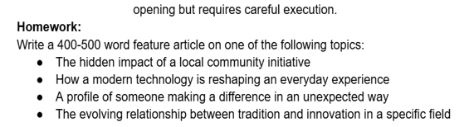

**How is modern technology reshaping our life**

Every day when we wake up, our minds start to crowd up. We think has anyone liked my Tik Tok post or is there another subscriber for my You tube channel right before we get out of our beds. Technology is around us- at home, school, we use it for videos, shorts, calls, games and many more.

**Communication, paying and research made easy**

Back in the olden times, people had to do many things in hand like paying bills, writing postcards to others by pen or pencil and had to wait for days or even weeks for some sort of reply and having to find the answers to the questions. [books, others, and more except for electronics]. Now with technology, everything is easier for us like for paying bills we can do online payment or instead of waiting for weeks just for a reply, you can just message or phone call and we can find all the answers to our questions on Google.

**How learning has changed a lot**

Ever since COVID19 happened students at school had online learning. Students used Google, You Tube and other websites and apps for research and to communicate with teachers and classmates. From the end of COVID19, teachers used Google Classroom or Sesaw or Teams to post homework online