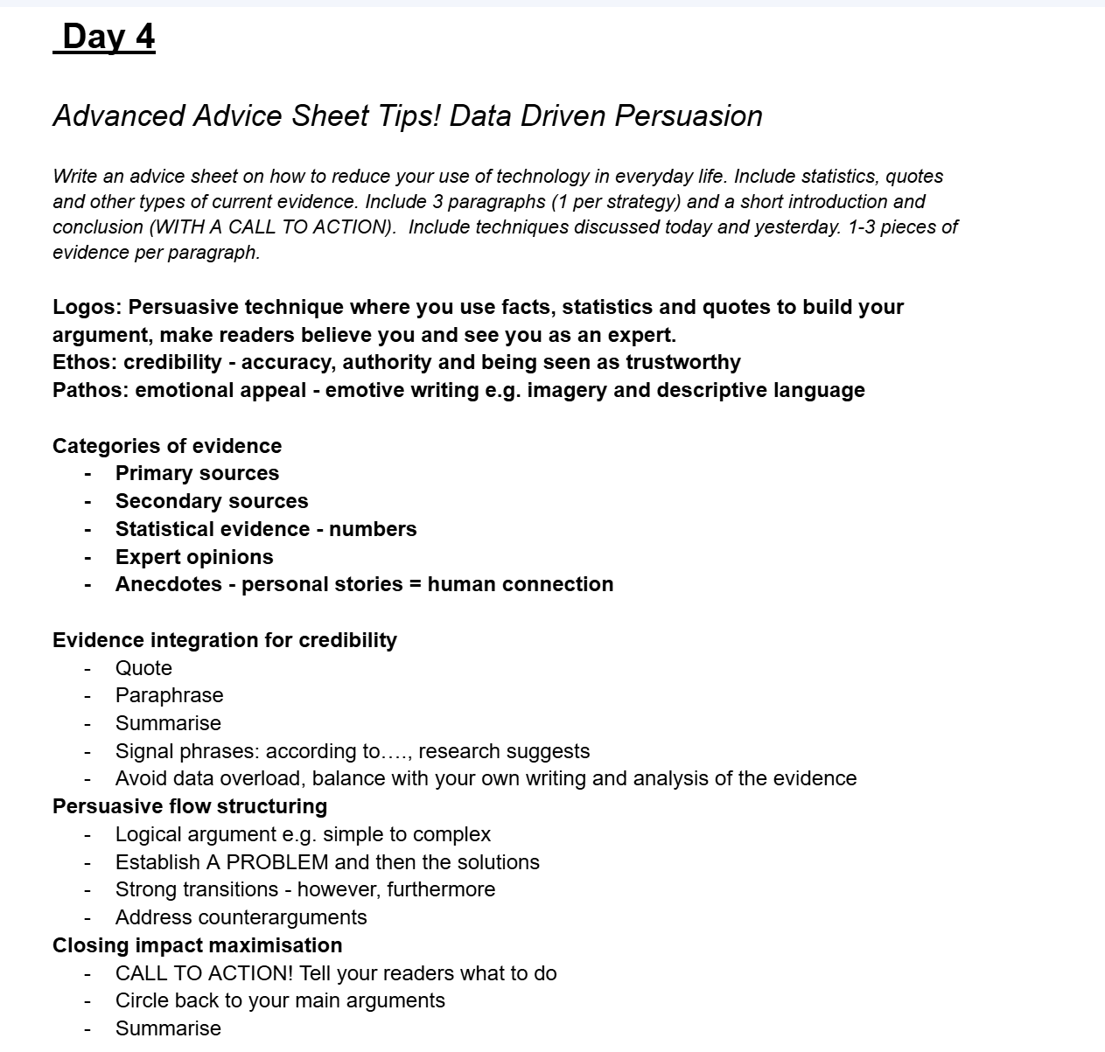

**Why Should We Reduce Technology?**

Have you ever spent so long on a screen that your eyes felt tired? Or some times you can’t see in class? These are all signs you have been watching too much screens.

Firstly, **too much screen time is bad for our health**. When we sit for hours watching videos or playing games, we are not moving our bodies. This can make us feel tired, lazy, or even sick. Our eyes can get sore, and we might not sleep well at night. According to Specsavers, they say, “Anyone who spends a significant amount of time in front of a computer screen can suffer from eye strain. This is also sometimes referred to by the umbrella term computer vision syndrome, which is used to describe a range of eye-related conditions. You may have heard of repetitive stress injuries associated with carrying out the same task - like typing on a computer keyboard - repeatedly. Eye strain is caused in a similar way. Your eyes must constantly move, focus and re-focus while you work at a computer screen - and without regular breaks, this can put strain on these important muscles. Additionally, elements including glare and contrast, as well as flickering, make reading and writing on a computer screen more challenging than when you read and write on paper.’’ Now can you understand this eye problem? This is what really happens when you watch too much. Still do you not think this is true? Then here care some other reasons why.

Secondly, we miss out on real life when we spend too much time on screens. Instead of talking to our family or playing with our friends, we are just connected to a screen. Playing outside, riding bikes, reading a book or other fun activities is much better for our brains and hearts. Spending time with friends with your devices down builds good memories, strengths and things that you can learn from each other. On the other hand, too much screen time can make us stressed, tired, and lonely. That is why it is so important to reduce the amount of time on our screens and social media right now and enjoy the real world around us—because real-life moments are the ones that truly matter.

Finally, technology can stop us from learning new things. We can learn from videos, but we also learn by exploring, asking questions, and doing things ourselves. If we are always on screens, we do not get to use our imagination as much. We do use internet for research but for some problems instead for scrolling on your electronics, you can use your prior knowledge and find it in books or ask different people and learn more. In the end, while technology can help us learn, it is important not to rely on it too much. Real learning also comes from curiosity, creativity, and interacting with the world around us.

In conclusion, technology can be helpful, but we should use it less. Let us spend more time being active, creative, and with the people around us. It is time to put the screens down and enjoy the world and fresh air around us and too which is way better than clicking on a screen. Never use your device at night and have a good time in the real world! :D